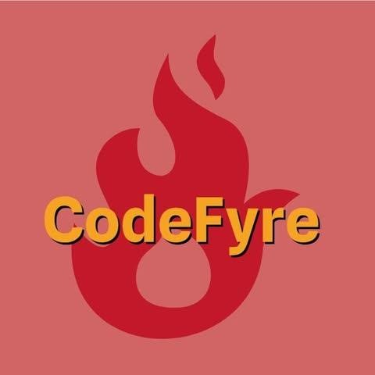

Documentation – “Code Fyre”

**Content**

TEAM………………………………….……………………………..1 PROJECTIDEA……………………………………………………2

PROJECT INFORMATION…………………………………….3 TECHNALOGIES USED………………………………………...4

WORK PLAN……………………………………………………….5

## **Quality Assurance (QA)………………………........................6**

# Team Members and Roles

## Frontend Developer – Milen Vassilev

Milen built the HTML and CSS layout of the web app. He used Bootstrap for responsiveness and ensured the interface worked on both desktop and mobile. He validated the code using the W3C validator and styled all UI components.

## Backend Developer – Kiril Zhipichev

Kiril implemented all JavaScript functions, including saving and filtering code blocks. He used localStorage for data persistence and worked on validating form inputs and improving user interaction through scripting.

## Designer – Dimitar Meshkov

Dimitar created the visual concept of Code Fyre. He selected fonts, colors (orange and black), and ensured consistency in the site’s look and feel. He also sourced legal imagery and icons for the interface.

## Scrum Trainer – Borimir Kirov

Borimir coordinated team meetings, tracked progress, and made sure tasks were assigned and completed on time. He used Scrum methodology to maintain team focus and workflow efficiency.

# Project Presentation

## Project Name: Code Fyre

**Team Members:** 4 (Frontend Developer, Backend Developer, Designer, Scrum Trainer)

**Project Type:** Web Application

## Purpose of the Project

The main goal of Code Fyre is to create an intuitive and modern platform where users— especially students and beginner developers—can share, view, and discuss code snippets in various programming languages. The platform promotes collaboration and learning through code visualization and interaction.

## Target Audience

* Students learning HTML, CSS, and JavaScript
* Beginner developers who want to practice and showcase their code
* Teachers who want to give coding tasks and receive submissions in an interactive environment

## Features

* User-friendly interface with clean navigation
* Sections for uploading and saving code snippets
* Filtering code by language (HTML, CSS, JS)
* Light/dark mode support for better readability
* Mobile-responsive design
* Visual consistency and modern layout using Bootstrap

## Tools and Technologies Used

* **HTML5**, **CSS3**, **JavaScript** – for building the core functionality
* **Bootstrap** – for styling and responsive layout
* **Font Awesome** – for icons
* **GitHub** – for version control and team collaboration
* **W3C Validator** – to ensure code quality and compliance

## Learning Outcomes

This project helped the team learn how to:

* Organize a development process using Scrum
* Work collaboratively using GitHub
* Apply modern web design principles
* Use JavaScript for real-world functionality
* Create accessible and responsive web content

1. **Plan & Research:** Study fire safety, define audience, list features, assign roles, set timeline.
2. Create wireframes, pick colors/icons, design logo and buttons.
3. **Frontend:** Build pages, quiz, drag-and-drop escape plan, interactive simulation, **Design:** checklist form, style responsively.
4. **Backend (optional):** Save data, validate forms, track progress.
5. **Test:** Cross-device/browser testing, validate code, debug, usability tests.
6. **Finish:** Optimize assets, write README, prepare presentation, deploy online.

## ****Quality Assurance (QA)****

To ensure that the Code Fyre documentation and application met high standards of quality, the following QA process was applied:

**Step 1: Check for Completeness**

* Verified that all documentation sections were included as per the content outline
* Confirmed all features were fully described

**Step 2: Verify Accuracy**

* Validated technical terms, tool names, and feature descriptions

**Step 3: Ensure Clarity**

* Ensured clear, straightforward explanations
* Avoided unnecessary words

**Step 4: Review for Consistency**

* Standardized formatting
* Maintained consistent terminology
* Kept writing tone official

**Step 5: Check Grammar and Spelling**

* Reviewed the entire document for spelling errors
* Used tools such as GrammarCheck

**Step 6: Final Presentation Review**

* Ensured layout was visually clean and well-structured
* Verified correct use of headings and bullet lists